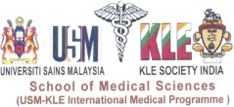
NAME : Dr. Wilma Carvalho
Present Designation : M. D
Department : Family Medicine
Photo :

Institute / College : USM-KLE International Medical Programme,
District Stadium Road, Nehru Nagar,
Belgaum, Karnataka, INDIA

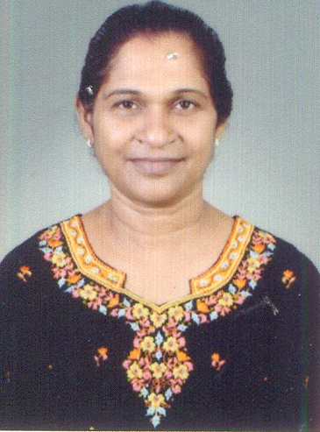

Passport
Size
Photo
Name |  |  | Dr. Wilma Carvalho
Designation
Department |  |  | Family Medicine
Date of Birth |  |  | Date: 15.10.1957 |  | Age: 57 Years
Qualification |  |  |  |  | Year of Passing
UG Degree |  |  | MBBS |  | October 1980
PG Degree |  |  | DCH |  | 1984
Others / Specialities |  |  | Registered for M. Med in Family Medicine |  | Will Pass in 2016
Residential Address |  | CASA Carvalho, Plot No. 5, Somnath Colony, 6th X Adarsh Nagar, Belgaum - 590011
Address for Correspondence |  | Same as Above
Contact No.: |  | Resi: 0831 - 2484228 |  | Mob: 9972711717
Medical Council Registration No. |  | 85152
Teaching Experience | Post | College / Institute |  | Duration
 | Tutor
 | Registrar | LTMG Hospital Mumbai |  | 2 Years
 | Lecturer
 | Assistant Professor
 | Associate Professor
 | Professor
 | HOD
Total Teaching Experience  (UG + PG) |  |  |  | 4 Years

Member of Local / National Body | 1.  2.  3.  4.  5.
 |  | Number of National | Number of International
Achievements
Awards
CME’s / Workshops |  | CSA CME
Publications
Journals
Presentations
Achievements | - HIV Training done under NACO  - Registered under the CMC Vellore for M. Med in Family Medicine  - Working in De Addiction centre  - M O in Support HIV Centre for 7 years
Awards | 1.  2.  3.  4.  5.
CME’s / Workshops | 1. CSA CME – National Level  2. Workshop done on TB in HIV- Bangalore  3.  4.  5.

Publications | 1.  2.  3.  4.  5.
Journals | 1.  2.  3.  4.  5.
Presentations | 1.  2.  3.  4.  5.
Others

